
HIT 0400 Project Proposal

IoT-Based Smart Office Automation System
By
Tapiwa Dube H230660E
Supervisor: Eng. Duri

A Research Project Proposal Submitted To Harare Institute Of Technology In Partial Fulfulment Of The Bachelor Of Technology (Honours) Degree In Electronic Engineering

September 2026

TABLE OF CONTENTS

Chapter 1: Introduction………………………………………………………………..5
Problem statement……………………………………………………………………..5
Problem solution……………………………………………………………………….5
Aim……………………………………………………………………………………..6
Objectives………………………………………………………………………………6
Justification……………………………………………………………………………..6
Scope of Study………………………………………………………………………….7
Chapter 2: Literature review…………..………………………………………………..8
Chapter 3: Methodology..……………………………………………………………....9
System block diagram………………………………………………………………....10
System description……………………………………………………………….……11
System flow chart……………………………………………………………………...12
Chapter 4: Expected results…………………..………………………………………..13
Chapter 5: Budget……………………………………..……………………………….14
Chapter 6: Timelines…………………………………………………………………...15
Gantt chart……………………………………………………………………………...15
References………………………………….…………………………………………..16

LIST OF FIGURES

Figure 1: System block diagram………………………………………………………………………………………….11
Figure 2: System flowchart…………………………………………………………………………………………………12
Figure 3: Gantt chart………………………………………………………………………………………………………….15

LIST OF TABLES
Table 3.1: Hardware components……………………………………………………………………………………….9
Table 4.1: Expected results…………………………………………………………………………………………….….13
Table 5.1: Estimated bill of materials………………………………………………..……………………………….14

CHAPTER ONE: Introduction

1.0 Background
Offices today rely heavily on electrically powered lighting, heating/cooling, and security infrastructure that is, in most buildings, still operated manually through wall switches, thermostats, and physical keys or manned access points. This manual approach depends entirely on the discipline of occupants to switch off appliances that are not in use, and it gives office occupants no real-time visibility into what is happening inside the building once they have left the premises.
The last decade has seen rapid growth in low-cost Internet of Things (IoT) hardware, most notably Wi-Fi-enabled microcontrollers such as the ESP32, along with lightweight messaging protocols such as MQTT and cloud platforms (Firebase, AWS IoT Core, ThingSpeak) that make it inexpensive to connect physical sensors and actuators to the internet. Combined with widely available modules such as PIR motion sensors, light-dependent resistors (LDRs), DHT22 temperature/humidity sensors, RFID readers, and small stepper motors, it is now practical for a small design team to build a working automated office system using off-the-shelf components rather than proprietary building-management hardware.
This proposal builds on that trend by presenting a smart office automation system that senses occupancy, ambient light, temperature and humidity, and access-control events, and reacts by automatically operating lights, HVAC-related relays, motorized curtains, and door access, while also streaming live status to a mobile app or web dashboard that an office occupant can view and use to override the system from anywhere with an internet connection.
1.1 Problem Statement
Traditional offices waste significant amounts of energy because lights, air-conditioning units, and other electrical equipment are frequently left running in rooms that are unoccupied, either because occupants forget to switch them off or because there is no automatic mechanism to do so. Curtains are opened and closed manually regardless of the actual sunlight level, which can lead to unnecessary heat gain or excessive artificial lighting use. In addition, most small and medium-sized offices have no remote visibility into the state of their building: an office occupant cannot tell, without physically walking through the building, whether lights are on, whether a room is too warm, or whether an unauthorised person has attempted to access a restricted area. This lack of automated, sensor-driven control and remote monitoring results in higher energy bills, reduced comfort, weaker security, and inefficient use of facilities staff time.
1.2 Problem Solution
The proposed solution is a centralized IoT-based office automation system built around an ESP32 microcontroller acting as the local "brain" of the office. The ESP32 continuously reads inputs from PIR motion sensors, an LDR, a DHT22 temperature/humidity sensor, an RFID/keypad access module, and limit switches on a motorized curtain assembly, and uses this data to make automatic decisions: switching lights on only when a room is occupied and ambient light is low, activating a fan/AC relay when temperature or humidity crosses a set threshold, granting or denying access based on RFID/keypad credentials, and opening or closing the curtain based on a real-time clock (RTC) schedule and the LDR reading.
At the same time, the ESP32 publishes all sensor readings and device states to a cloud-based MQTT broker (such as HiveMQ, Firebase, or ThingSpeak), which feeds a mobile app or web dashboard. This gives an office occupant live visibility into the state of the office from anywhere, together with the ability to manually override any automated decision remotely. In combination, the automatic sensor-driven logic and the remote dashboard directly address the energy waste, comfort, and visibility problems identified above.
1.3 Aim
The aim of this project is to design and build a low-cost, ESP32-based IoT office automation system that automatically controls lighting, climate-related appliances, motorized curtains, and door access using embedded sensors, while providing an office occupant with real-time remote monitoring and manual override capability through a mobile app or web dashboard.
1.4 Objectives
- To design and implement an occupancy- and light-aware automatic lighting control subsystem using PIR motion sensors and an LDR interfaced to a relay module.
- To develop a climate-control subsystem that switches a fan/AC relay (or drives an IR blaster) based on temperature and humidity readings from a DHT22 sensor.
- To implement an access-control and intrusion-alert subsystem using an RFID/keypad reader with timestamped logging, supported by an ESP32-CAM for visual verification.
- To design and build a motorized curtain-control subsystem that opens and closes automatically according to an RTC-based schedule and ambient light level, with limit switches to prevent motor over-run.
- To develop an ESP32-based central hub that aggregates all sensor and device data and publishes it to a cloud MQTT broker for remote access.
- To build a mobile app or web dashboard that displays live sensor/device status and allows a user to remotely override any automated function.
1.5 Justification
This project is justified on several grounds. First, energy costs form a significant part of an office's recurring operating expenses, and automatically switching off lighting and climate-control appliances when rooms are unoccupied directly reduces wasted electricity and supports organisational sustainability goals. Second, remote visibility into building status allows a single facilities manager to oversee multiple rooms, or even multiple sites, without needing to be physically present, which is increasingly important given the rise of hybrid and remote working arrangements. Third, automated, logged access control improves security and accountability compared with manually managed keys. Fourth, the hardware selected, including the ESP32, PIR, LDR, DHT22, RFID, and stepper-motor modules, is inexpensive and widely available, meaning the resulting system can realistically be prototyped and eventually scaled at low cost. Finally, the project provides an opportunity to apply and demonstrate practical skills in embedded systems, sensor interfacing, wireless communication (MQTT/Wi-Fi), cloud integration, and mobile/web dashboard development, all of which are directly relevant to current industry demand for IoT engineers.
1.6 Scope of Study
This project covers the design, prototyping, and testing of a single-room (scalable to a small office/floor) IoT automation system comprising four functional modules (lighting, climate, security/access, and curtain control) coordinated by a single ESP32 hub and connected to a cloud MQTT broker and a mobile/web dashboard. The prototype will demonstrate automatic sensor-driven control, data logging, remote monitoring, and manual override.

CHAPTER TWO: Literature Review

2.1 IoT platforms for building/home automation
Zanella et al. (2014) describe how the Internet of Things enables heterogeneous physical devices to be connected transparently to the internet so that their data can be exposed to a wide range of digital services, and they illustrate this with an urban IoT deployment (the Padova Smart City project) that combines low-power sensor nodes with a common IP-based gateway. The same architectural pattern, many small sensor/actuator nodes reporting through a single gateway, underlies most smart-building and smart-office systems, including the one proposed here, where the ESP32 hub plays the role of the local gateway.
2.2 MQTT as a communication protocol for constrained devices
Kodali and Soratkal (2016) present an implementation of the MQTT protocol on the ESP8266 Wi-Fi module for a home-automation prototype, highlighting that MQTT's lightweight publish/subscribe model is well suited to small, power- and bandwidth-constrained IoT devices connected through a common Wi-Fi gateway, and that it improves comfort, energy efficiency, indoor security and cost savings relative to purely manual control. Their findings support the choice of MQTT (rather than a heavier protocol such as HTTP polling) as the communication layer between the ESP32 hub and the cloud broker in this project.
2.3 Sensor-based automatic lighting and climate control
Prior automation prototypes commonly combine a passive infrared (PIR) sensor for occupancy detection with a light-dependent resistor (LDR) for ambient-light sensing, so that lighting is switched on only when a room is both occupied and dim, a logic pattern this project adopts directly. Similarly, temperature/humidity sensors such as the DHT22 are widely used as the trigger for relay-controlled fans or air-conditioning, since they provide a simple digital reading that can be compared against a configurable threshold without requiring a full building-management-system integration.
2.4 RFID-based access control
RFID readers such as the MFRC522 are a standard low-cost method of implementing electronic access control in embedded projects, typically paired with a keypad as a secondary or backup authentication method and a microcontroller log of timestamped access events. Adding a camera module, such as the ESP32-CAM used in this project, extends this pattern with a visual record that can be transmitted alongside an intrusion alert.
2.5 Gaps this project addresses
Much of the published literature demonstrates individual subsystems in isolation, such as lighting control, climate control, or access control, rather than combining lighting, climate, curtain automation, and security into a single, centrally coordinated, cloud-connected office system with a unified mobile/web dashboard. This project's contribution is to integrate these four subsystems around one ESP32 hub and one MQTT-based dashboard, specifically targeting an office context rather than a private home.
CHAPTER THREE: Methodology

3.1 System Design
The system follows a hub-and-spoke architecture. An ESP32 microcontroller acts as the central hub, connected over Wi-Fi to a cloud MQTT broker. Four peripheral modules are wired to the hub's GPIO pins and communicate their state to it: the lighting module (PIR + LDR + relay), the climate module (DHT22 + relay/IR blaster), the security module (RFID/keypad + ESP32-CAM), and the curtain module (stepper motor + limit switches + DS3231 RTC). A regulated power-supply unit (PSU) supplies stable DC power to the ESP32 and all peripheral modules. On the software side, ESP32 firmware written in the Arduino IDE / ESP-IDF (C/C++) reads all sensors on a fixed polling loop, applies threshold- and schedule-based decision logic, drives the relays and motor accordingly, and publishes status/telemetry to the MQTT broker, from where a mobile app (Blynk, or a custom Flutter/React Native app) or web dashboard subscribes to display live data and issue manual override commands back to the ESP32.
Table 3.1: Hardware components
Component | Function in the System
ESP32 development board | Main controller; Wi-Fi connectivity; runs control logic; MQTT client
PIR motion sensor | Detects room occupancy for lighting control
LDR (light-dependent resistor) | Senses ambient light for lighting and curtain logic
DHT22 sensor | Measures temperature and humidity for climate control
Relay module | Switches AC mains circuits for lights and fan/AC
RFID reader (RC522) / keypad | Access control at the office door, with timestamp logging
ESP32-CAM (optional) | Captures images for intrusion alerts
Stepper motor (28BYJ-48) + ULN2003 driver, or small DC geared motor | Drives the curtain rod/pulley mechanism
Curtain track + pulley/belt mechanism | Converts motor rotation into linear curtain movement
Limit switches (×2) | Detect fully-open/fully-closed curtain positions and prevent motor over-run
DS3231 RTC module | Provides accurate time for schedule-based curtain and lighting control
Regulated power supply unit | Supplies stable DC power to the ESP32 and all connected modules

3.2 Software stack
- Firmware: Arduino IDE / ESP-IDF (C/C++) running on the ESP32.
- Communication protocol: MQTT, a lightweight publish/subscribe messaging protocol suited to constrained IoT devices.
- Backend/cloud: Firebase Realtime Database, AWS IoT Core, or ThingSpeak for data storage and device shadowing.
- Frontend: Blynk app for rapid prototyping, or a custom Flutter/React Native app and/or web dashboard for a more complete final demonstration.
3.3 System Block Diagram
The block diagram below shows the ESP32 central hub at the core of the system, interfacing with the four peripheral modules (lighting, climate, security, curtain) and the power-supply unit on one side, and with the cloud MQTT broker and mobile/web dashboard on the other, enabling both local automated control and remote monitoring/override.
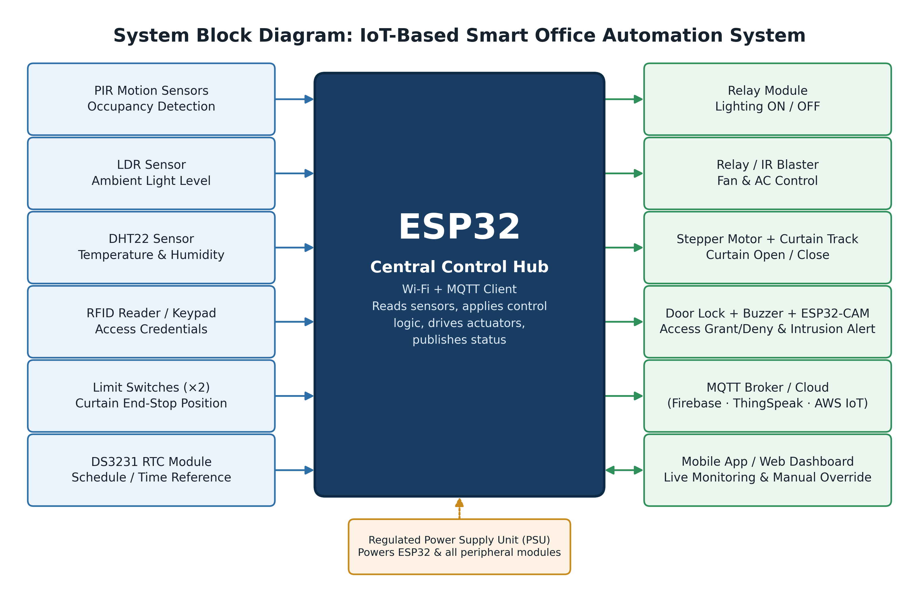
Figure 1: System block diagram of the IoT-Based Smart Office Automation System.

3.4 System Description
On power-up, the ESP32 initializes all connected sensors and actuators and establishes a Wi-Fi connection followed by an MQTT session with the cloud broker. During normal operation, the firmware repeatedly polls the PIR sensor and LDR to decide whether to switch the room lights on or off through the relay module; polls the DHT22 sensor to decide whether the fan/AC relay (or IR blaster) should be activated; checks the RFID/keypad module for access attempts, granting entry and logging a timestamp for valid credentials while triggering an alert (optionally with an ESP32-CAM snapshot) for invalid ones; and checks the RTC and LDR to decide whether the curtain motor should open or close the curtains, using the limit switches to stop the motor safely at the end positions.
After each control cycle, the ESP32 publishes the current sensor readings and device states to the MQTT broker, which updates the mobile app / web dashboard in real time. A user with appropriate access can view this live status from anywhere with an internet connection and issue a manual override command, for example forcing the lights on, closing the curtain early, or unlocking the door, which is delivered back to the ESP32 over the same MQTT channel and takes precedence over the automatic logic until control is returned to automatic mode.

3.5 System Flowchart
The flowchart below summarises the ESP32 firmware's main control loop, from initialization through sensor reading, decision-making for each subsystem, cloud publishing, dashboard update, and handling of manual override commands, before looping back to read sensors again.
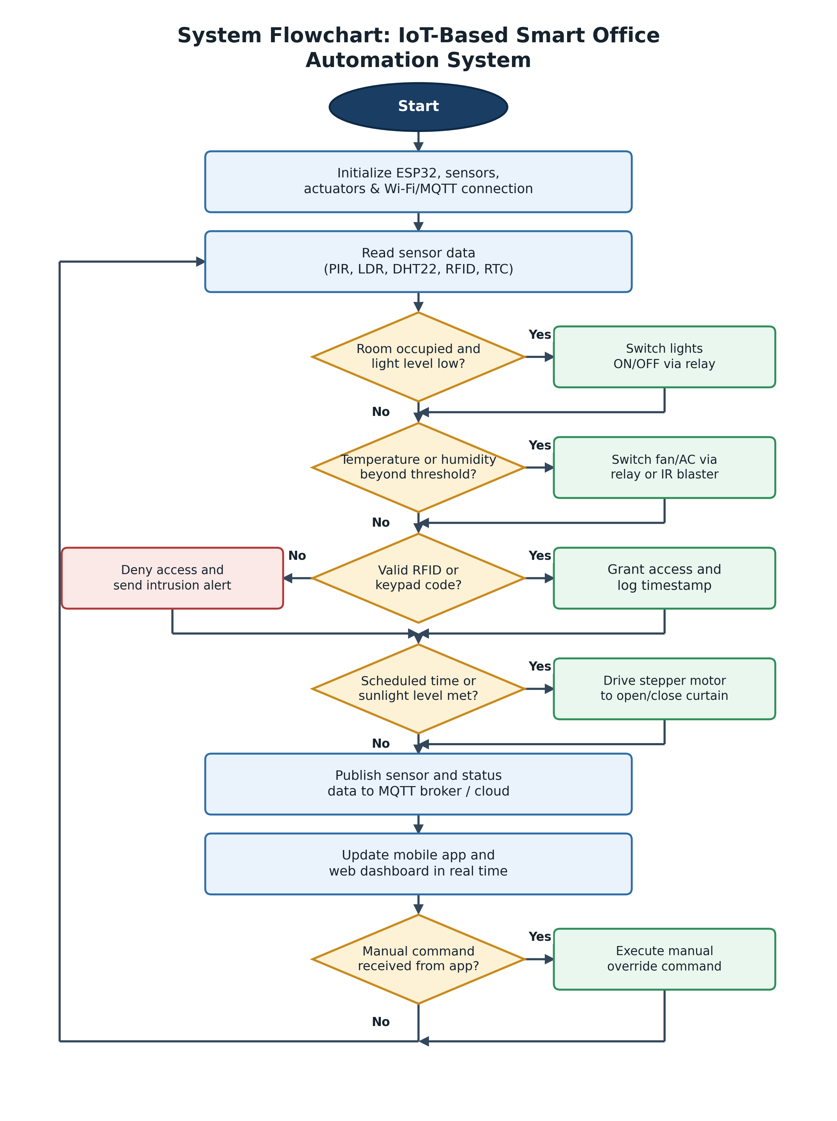
Figure 2: System flowchart showing the ESP32 firmware's main control logic

CHAPTER FOUR: Expected Results

4.1 Expected Results
On completion, the project is expected to produce a working prototype that demonstrates the outcomes in Table 4.1 below:
Table 4.1: Expected results
S/N | Subsystem | Expected Result
1 | Lighting Control | Automatic switching of lighting based on occupancy and ambient light, reducing unnecessary lighting energy use in unoccupied or well-lit rooms.
2 | HVAC Control | Automatic activation of fan/AC control when temperature or humidity crosses configured thresholds, improving comfort without requiring manual adjustment.
3 | Access Control | Reliable RFID/keypad-based access control with a timestamped access log and alerts for unauthorised attempts.
4 | Curtain Automation | Automatic, schedule- and light-based curtain operation with safe end-stop detection via the limit switches.
5 | Monitoring Dashboard | A live mobile app / web dashboard accurately reflecting the real-time state of all subsystems.
6 | Remote Override | Successful remote manual override of each subsystem from the dashboard, confirmed by observing the corresponding physical actuator response.

CHAPTER FIVE: Budget

Table 5.1: An estimated bill of materials
Item | Qty | Est. Unit Cost (USD) | Est. Total (USD)
ESP32 development board | 1 | $8 | $8
ESP32-CAM module | 1 | $9 | $9
PIR motion sensor | 2 | $2 | $4
LDR module | 2 | $1 | $2
DHT22 temperature/humidity sensor | 1 | $6 | $6
4-channel relay module | 1 | $4 | $4
RFID reader (RC522) + tags | 1 | $4 | $4
4×4 matrix keypad | 1 | $3 | $3
Stepper motor (28BYJ-48) + ULN2003 driver | 1 | $4 | $4
Curtain track, pulley/belt mechanism | 1 | $15 | $15
Limit switches | 2 | $1 | $2
DS3231 RTC module | 1 | $3 | $3
Regulated power supply unit (5V/12V) | 1 | $10 | $10
Jumper wires, casing, misc. hardware | 1 set | $15 | $15
Cloud/hosting (ThingSpeak/Firebase free tier, MQTT broker) | N/A | $0 | $0
Estimated total prototype cost: approximately $98 (USD)
CHAPTER SIX: Timelines

6.1 Gantt Chart
The proposed implementation is planned over a 30-week schedule, from literature review and requirements gathering through design, procurement, hardware assembly, firmware and dashboard development, integration and testing, to final documentation and submission.
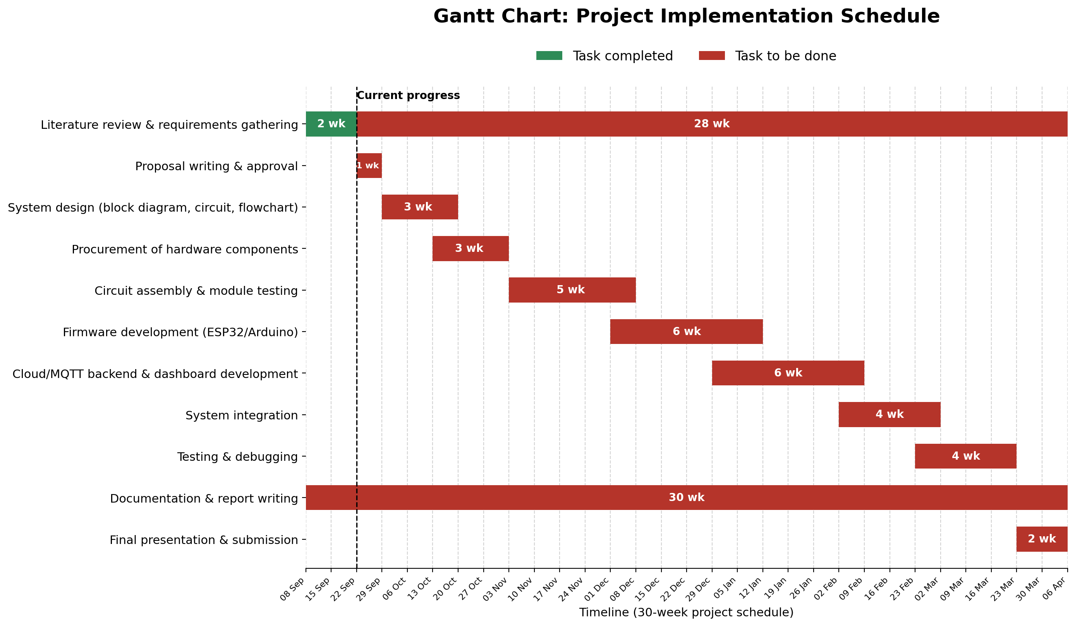
Figure 3: Gantt chart showing the planned 30-week project implementation schedule.

References
- Zanella, A., Bui, N., Castellani, A., Vangelista, L. and Zorzi, M. (2014) 'Internet of Things for Smart Cities', IEEE Internet of Things Journal, 1(1), pp. 22–32.
- Kodali, R.K. and Soratkal, S. (2016) 'MQTT Based Home Automation System Using ESP8266', in Proceedings of the 2016 IEEE Region 10 Humanitarian Technology Conference (R10-HTC), Agra, India, pp. 1–5.
- Bahga, A. and Madisetti, V. (2014) Internet of Things: A Hands-On Approach. Charleston: VPT Press.
- Espressif Systems (2023) ESP32 Series Datasheet. Shanghai: Espressif Systems.
- Aosong Electronics Co., Ltd. (n.d.) DHT22 Digital-Output Relative Humidity & Temperature Sensor Datasheet. Guangzhou: Aosong Electronics.
- NXP Semiconductors (n.d.) MFRC522 Standard Performance MIFARE and NTAG Frontend Datasheet. Eindhoven: NXP Semiconductors.
- OASIS (2019) MQTT Version 5.0 Specification. OASIS Standard. Available at: https://docs.oasis-open.org/mqtt/mqtt/v5.0/mqtt-v5.0.html
- MathWorks (n.d.) ThingSpeak IoT Analytics Platform Documentation. Available at: https://thingspeak.mathworks.com
- Google (n.d.) Firebase Realtime Database Documentation. Available at: https://firebase.google.com/docs/database
- Blynk Inc. (2024) Blynk IoT Platform Documentation. Available at: https://docs.blynk.io

